**Library module**

**IPT - PROJECT**

**19K-0281 ANUSHA SAAD**

**19K-0354 SAMAN KHAN**

**19K-1517 HERMAIN QADIR**

**Section: H**

**SCHEMMA:**

Author(author_id,name)

student(std_id, name , dep , password)

admin(username/id, password, full name)

book_master(book_id, book_name, genre, author_id, editon, current_stock, language)

book_issue( std_id, book_id, issue_date, due_date)

**Class Diagram:**

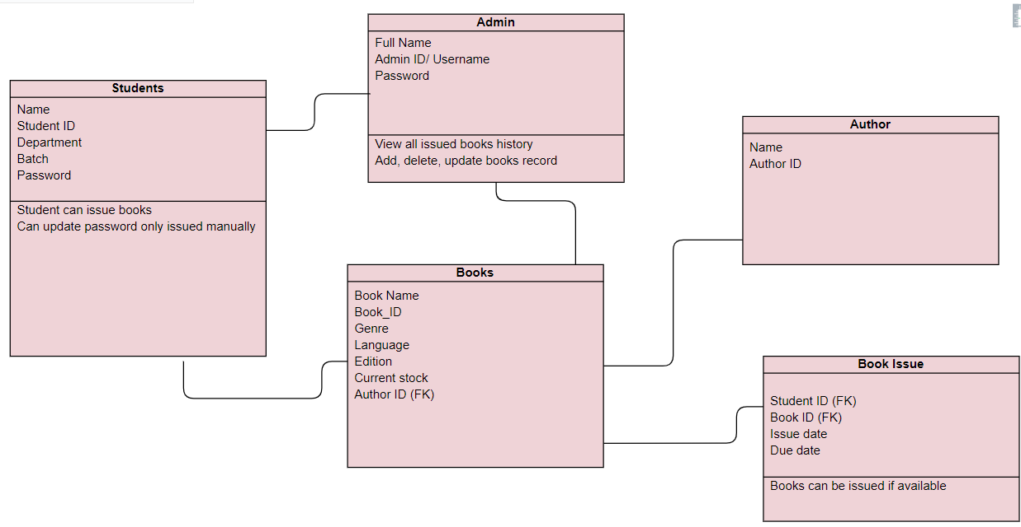

**Query to generate Database:**

CREATE TABLE Author (

auth_id VARCHAR(20) NOT NULL,

Name VARCHAR (25) NOT NULL,

PRIMARY KEY (auth_id));

CREATE TABLE Student (

std_id VARCHAR(20) NOT NULL,

Name VARCHAR(25) NOT NULL,

dept CHAR(5) NOT NULL,

Password VARCHAR(20) NOT NULL,

PRIMARY KEY( std_id ) );

CREATE TABLE Admin (

Id VARCHAR(20) NOT NULL,

Name VARCHAR(25) NOT NULL,

Password VARCHAR(20) NOT NULL,

PRIMARY KEY( id ) );

CREATE TABLE Book_Master(

b_id VARCHAR(20) NOT NULL,

Name VARCHAR(25) NOT NULL,

Genre VARCHAR(15),

author_id VARCHAR(20) FOREIGN KEY REFERENCES Author(auth_id),

Edition INT NOT NULL,

Stock INT NOT NULL,

Language VARCHAR(15),

PRIMARY KEY( b_id ) );

CREATE TABLE Book Issue(

s_id VARCHAR(20) FOREIGN KEY REFERENCES Student(std_id),

b_id VARCHAR(25) FOREIGN KEY REFERENCES Book_Master(b_id),

Issue DATE,

Due DATE,

CONSTRAINT CHK_1 CHECK (due>=issue)

);